From: https://www.euroweeklynews.com/2020/04/03/the-wuhan-connection-does-new-evidence-reveal-why-northern-italy-became-the-nations-coronavirus-epicenter/
Date: 20200403 April 3, 2020
The Wuhan Connection – Does new evidence reveal why Northern Italy became the nation’s coronavirus Epicenter?
By Tony Winterburn
3 April 2020 @ 12:23
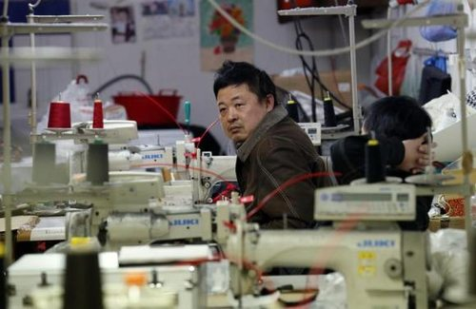Made in Italy by Chinese Workers-over 300,00 Chinese People live in Italy
IT is the question medics and researchers were asking themselves as Lombardy and Bergamo in northern Italy became known as the epicentre of the coronavirus crisis.
Perhaps these new revelations will go some way in explaining this…
The answer lies in the connection between northern Italy and Wuhan, China. Two very seemingly distant geographies are actually extremely tied together.

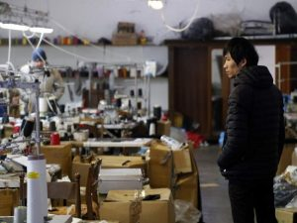Is There A Connection Between Luxury Fashion Brands’ Dirty Underground Secret And Italy’s Coronavirus Crisis?
Italy was the first country to offer direct flights from Europe to China 50 years ago and was also the first G-7 country to embrace China’s Belt and Road Initiative.
Northern Italy has a very prosperous fashion and clothing industry. Many of the most famous brands around the world from Gucci to Prada originated in the region. As China has offered cheaper manufacturing for their clothing factories, more and more Italian fashion houses have outsourced work to China, and specifically to Wuhan.
Italy created direct flights from Wuhan and allowed over 100,000 citizens from China to move to Italy and work in their factories. In addition, as the Chinese became increasingly wealthy over the last two decades, more and more Chinese citizens moved to northern Italy to reside and many Chinese purchased Italian firms.

Today there are now more than 300,000 Chinese nationals living in Italy, according to Fortune Magazine, and over 90 per cent of them work in Italy’s garment industry. Many of the Chinese workers flew back to Italy after the Chinese New Year just before the flight ban was introduced.
With Italy having the second oldest population in the world, many fear the worst is yet to come.

